Chapter 12, Solution 27.
Since Z_{L} and 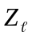 are in series, we can lump them together so that
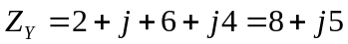
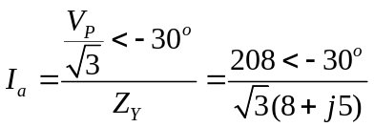
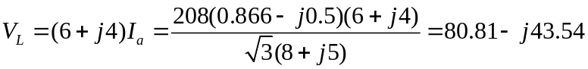

|V_{L}| = 91.79 V

